Customer Order Summary Analysis

- Project Overview:
This is a data analytics project to analyze customer order summary data. This project demonstrates a complete end-to-end data analytics workflow, starting from data loading and preprocessing using Python (Pandas), performing structured data analysis in SQL Server, and finally building an interactive Power BI dashboard to visualize key business insights.
The primary objective of this project is to analyze customer order data to generate actionable insights related to:
- Revenue performance
- Profit analysis
- Regional sales distribution
- Channel performance
- Order status tracking

- Dataset Summary:
The dataset consists of order-level data with 330 rows and 17 columns. Each order has assigned a unique order_id (Primary key).
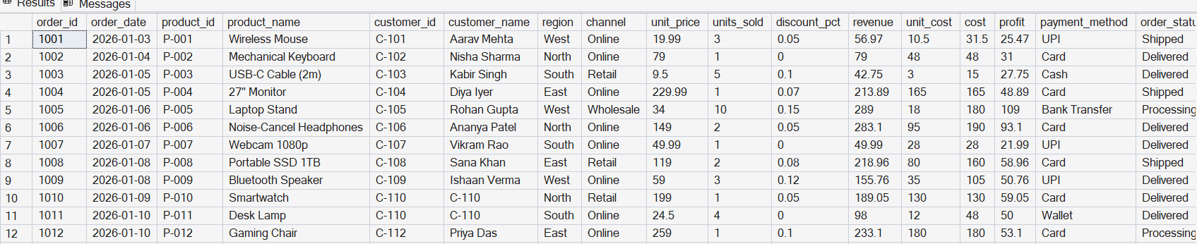

- Data cleansing and loading (Python):
Imported Excel file using Pandas
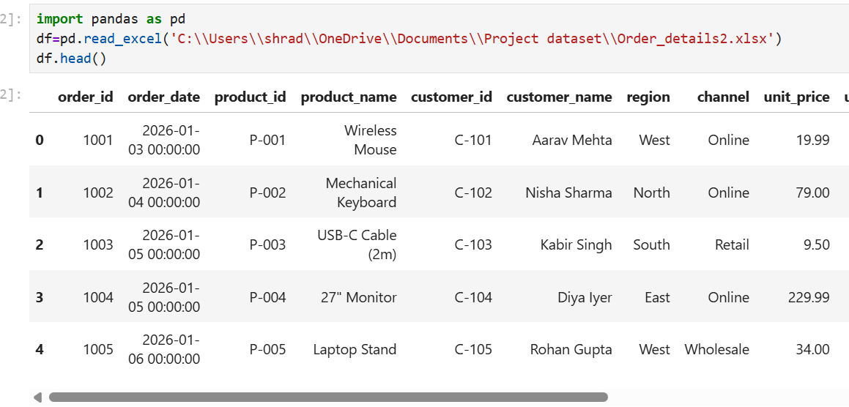
Performed data cleansing to check for missing/ null values. Explored the dataset using df.info()

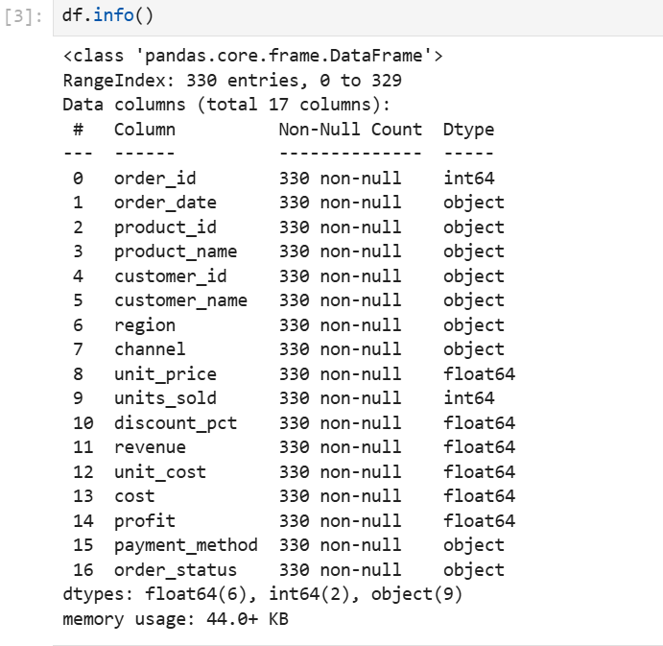
Df.describe(include=’all’) helps to understand the data types.
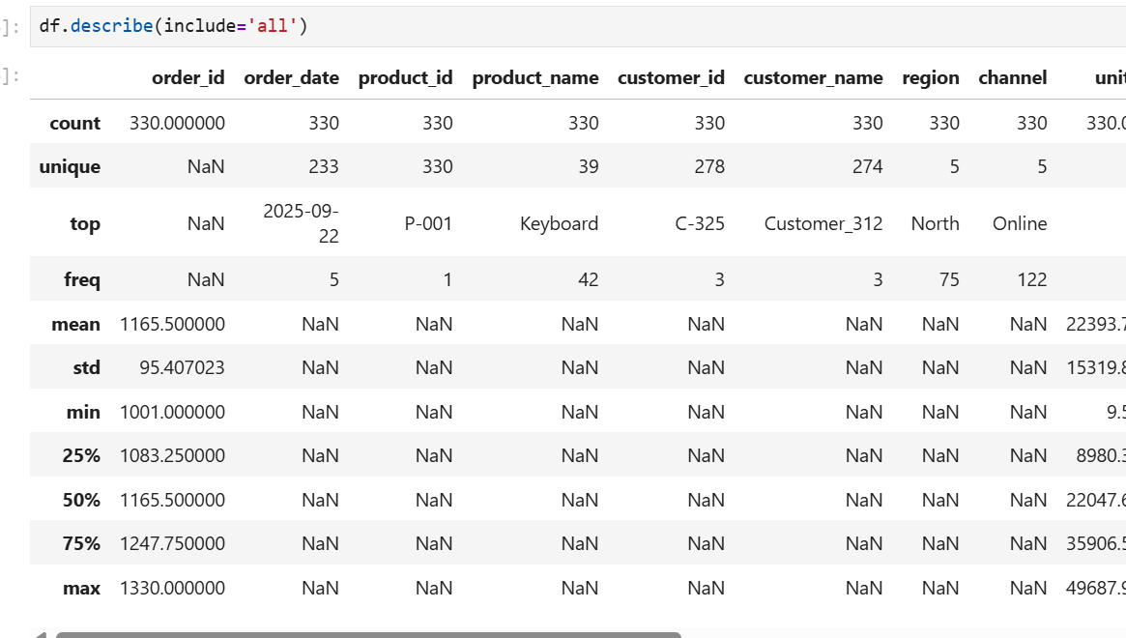

Isnull() helps to understand if there are any null or missing values.
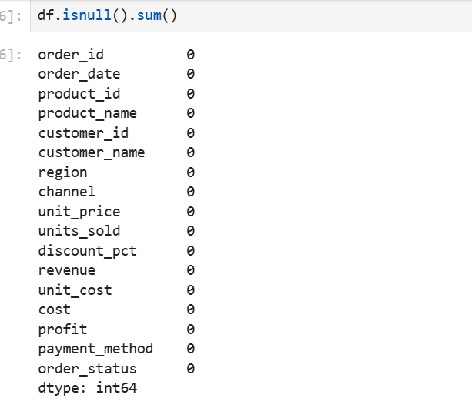

Updated the column names as per standard names with “_”
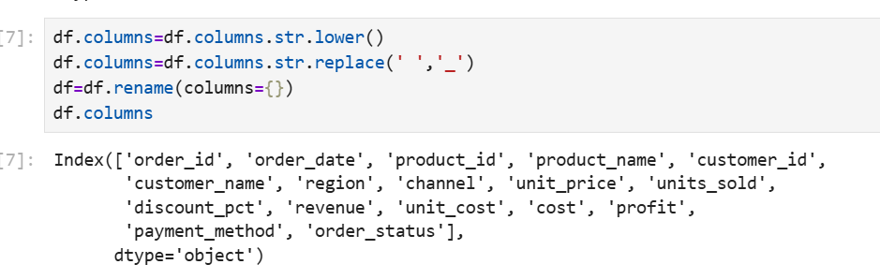

Installed sqlalchemy pyodbc to export data to SQL Server
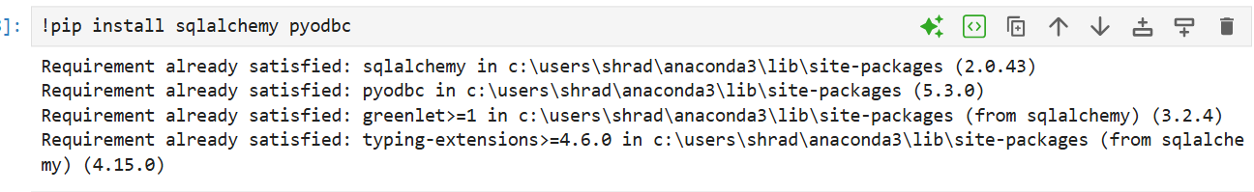

Exported data to SQL Server with the help of pandas, sqlalchemy and pyodbc.
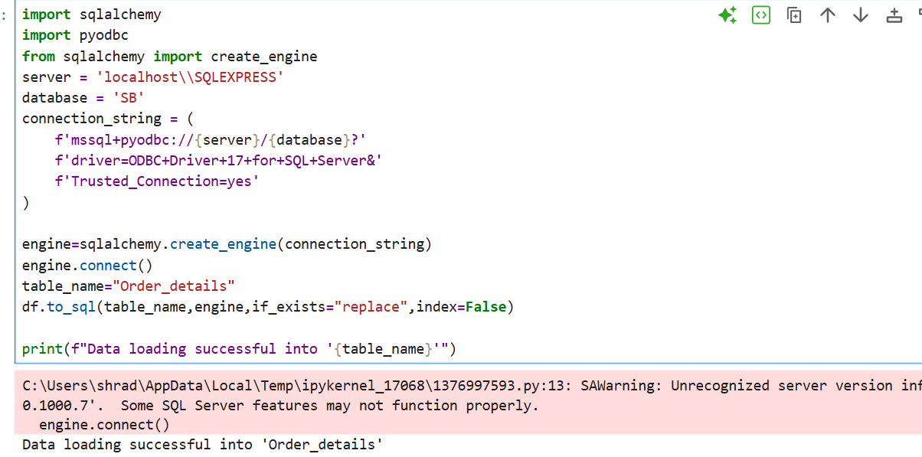

- Data analysis using SQL:
The order_details table is available in SQL Server. After understanding the data, created sql queries to get business insights.

- Get total revenue generated for each channel. Which channel is most profitable?
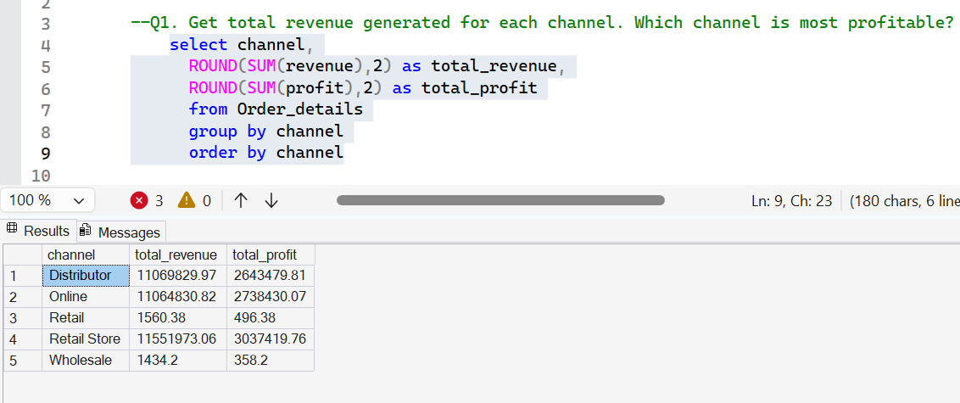

- Find percentage of orders delivered vs other status for each region
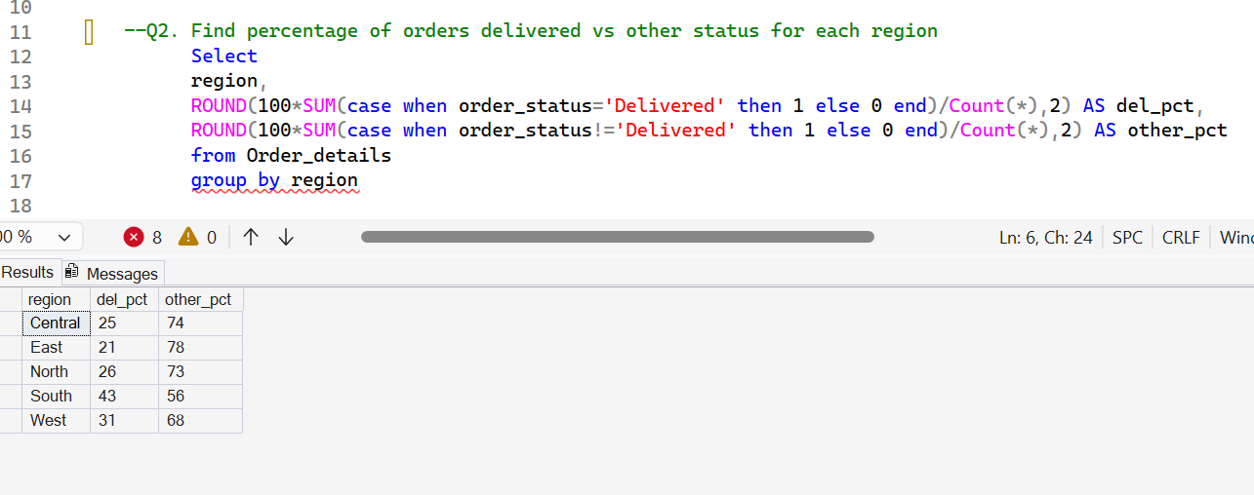
- Which products drive maximum profit?
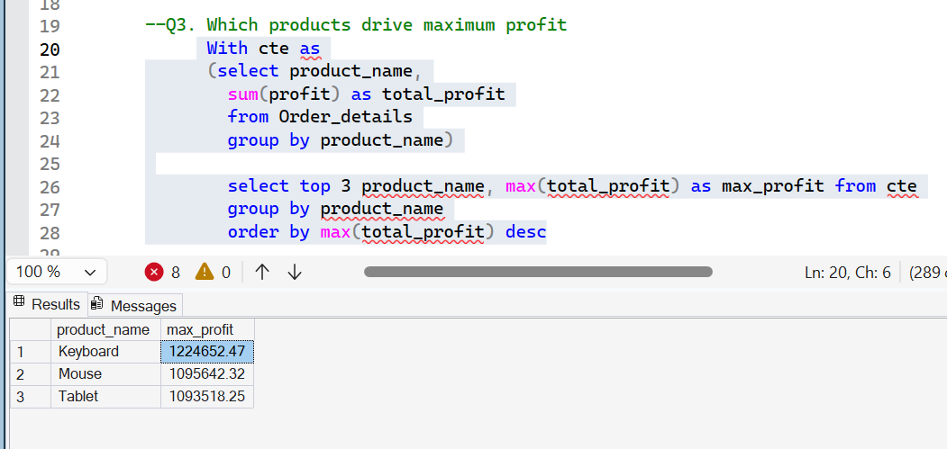

4.Calculate total revenue and sales for each product
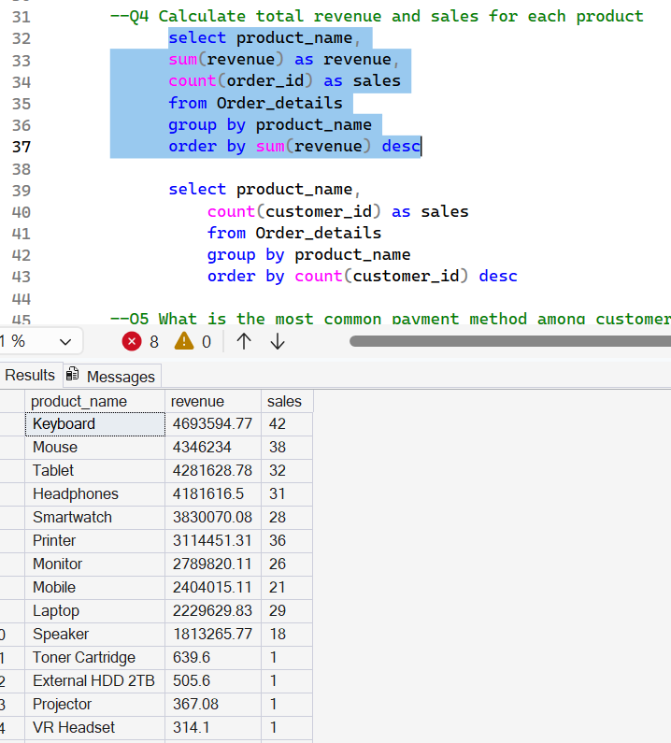

5.What is the most common payment method among customers?
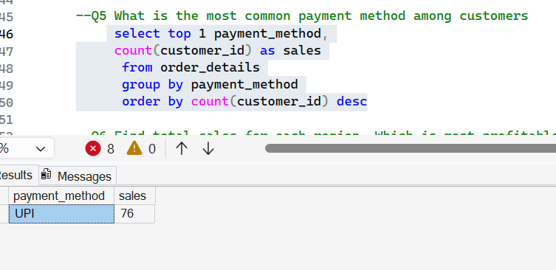

6. Find total sales for each region. Which is most profitable?
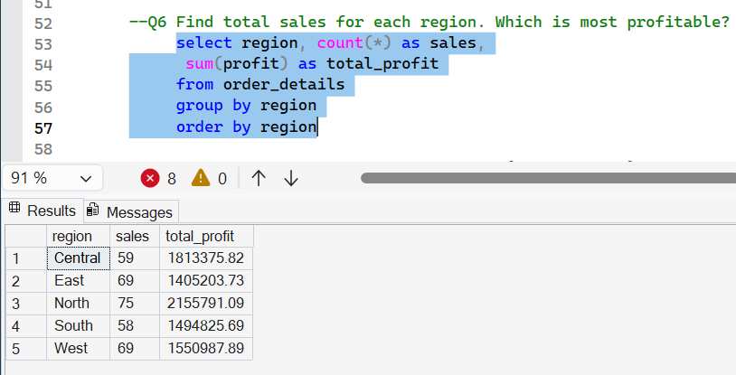

7. Are discounts eating our profit?
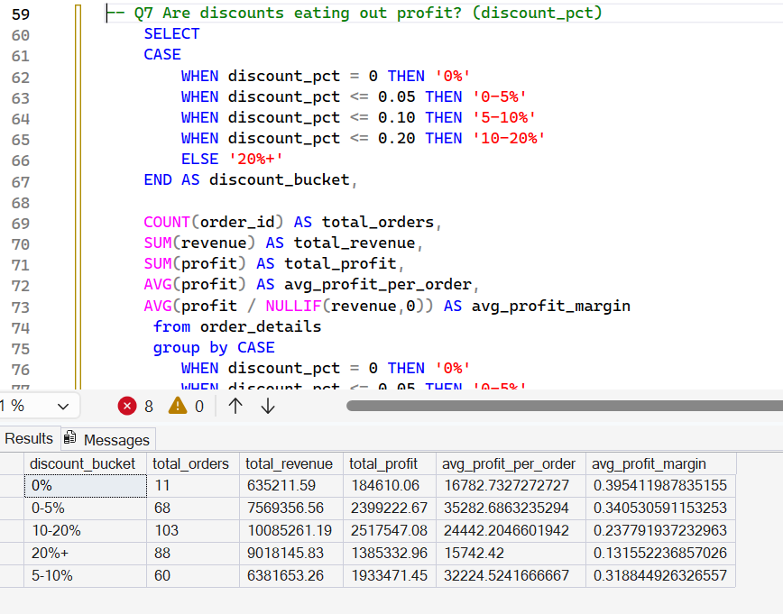
8.Compare revenue and profit over time
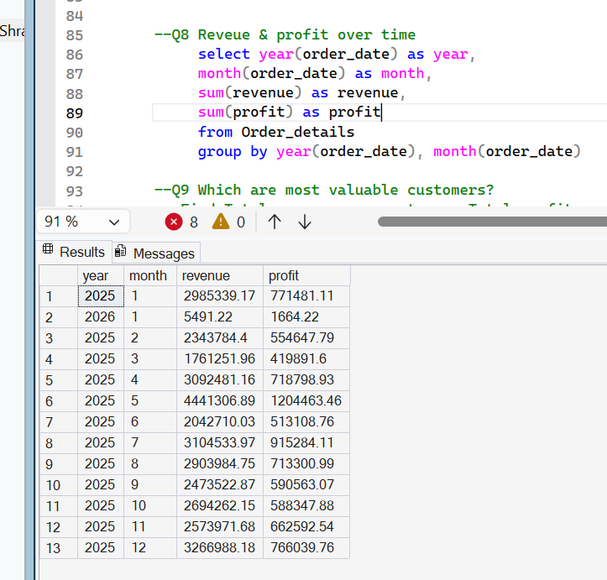
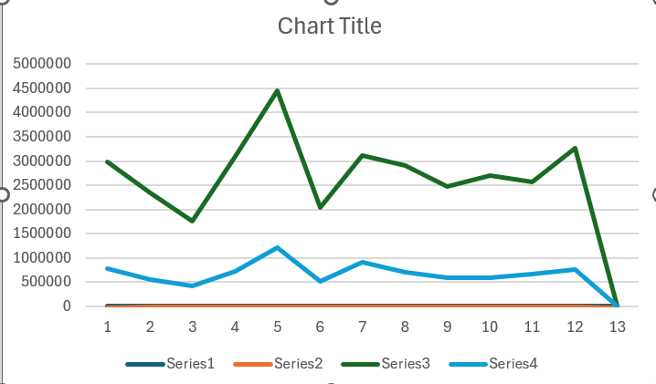

9. Who are most valuable customers?
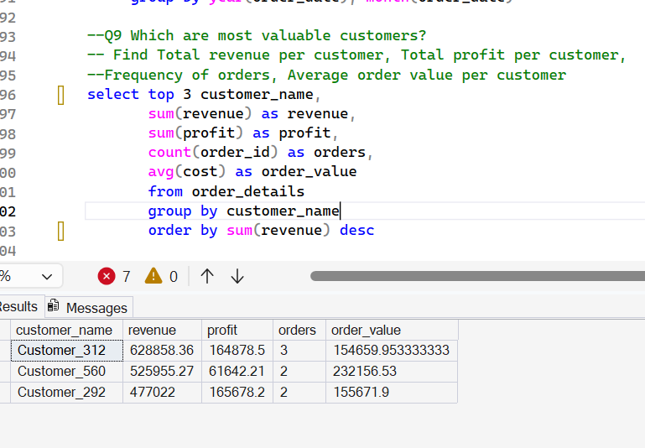

10. What is product_name and customer for highest profit order
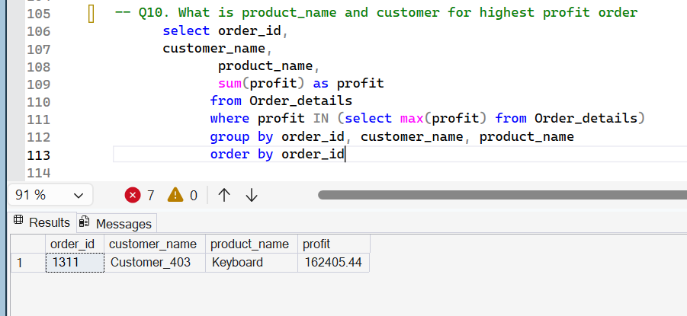

11.Total repeat customers
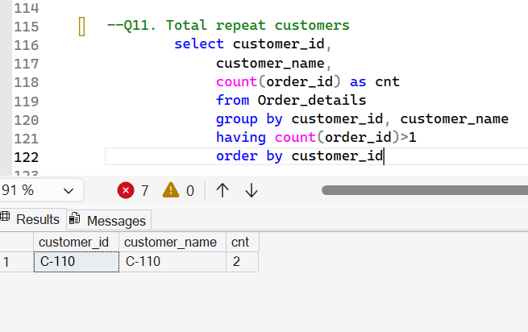
- Power BI Dashboard:
Created Customer Order Summary Dashboard to showcase revenue and profits by region and channel.
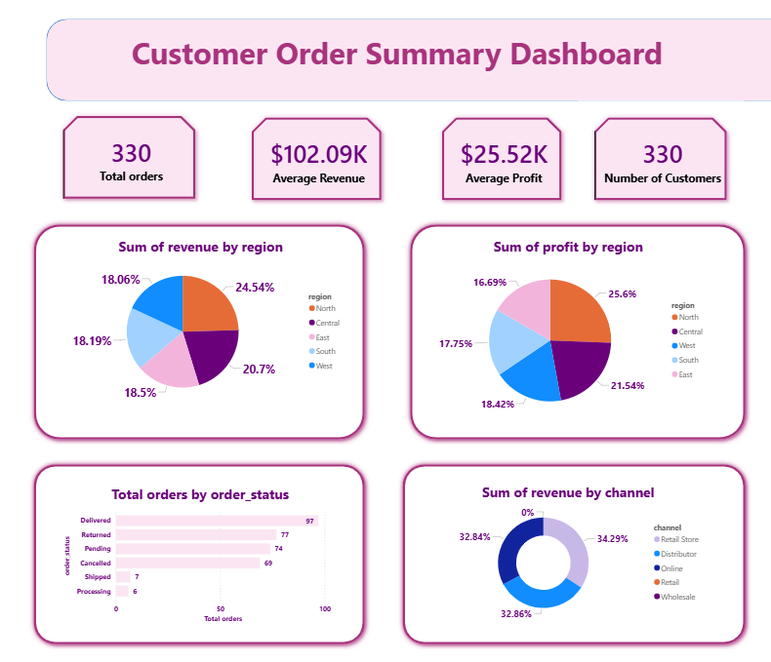

- Business Insights and Recommendation:
- Most of the profits and revenue are generated in the North region.
- Products that drive the most profit are Keyboard, Mouse and Tablet.
- Most revenue & profit are generated by Retail Stores(34%).
- Revenue and profit were highest in the month of May which indicates when customers go for shopping. We can create promos and discounts to increase revenue.
- Average profit margin is least (13%) when discount rate is above 20%. We can consider discount to increase profit margin.
- Most common payment method is UPI. So, making this payment method available everywhere may lead to more sales.

